Lab#3. Design Placement Dashboard page using HTML and CSS.

TAGS USED | ATTRIBUTES USED | DESCRIPTION
<DOCTYPE> | — | Declares the document type as HTML5.
<HTML> | LANG | Defines the root of the HTML document. LANG specifies the language of the webpage.
<HEAD> | — | Contains metadata and other information about the webpage.
<META> | CHARSET, NAME, CONTENT | Defines character encoding and viewport settings for responsive display.
<TITLE> | — | Defines the title of the webpage shown in the browser tab.
<LINK> | REL, HREF, TYPE | Links an external CSS file to the HTML document.
<BODY> | — | Contains the visible content of the webpage.
<HEADER> | CLASS | Defines the header section of the webpage.
<DIV> | CLASS | Defines a division or section of the webpage. Used here for the logo, container, cards, and individual cards.
<NAV> | CLASS | Defines the navigation section containing links such as Home, About, Contact, and Login.
<A> | HREF | Creates hyperlinks for navigation. HREF specifies the destination of the link.
<ASIDE> | CLASS | Defines a sidebar containing additional navigation links.
<MAIN> | CLASS | Defines the main content area of the webpage.
<H2> | — | Defines a level-2 heading, used for "Recent Placements".
<H3> | — | Defines a level-3 heading, used for student names.
<IMG> | SRC, ALT | Displays an image. SRC specifies the image location and ALT provides alternative text.
<P> | — | Defines a paragraph of text, used for company names and package information.
<FOOTER> | — | Defines the footer section of the webpage.
&copy; | — | Displays the copyright symbol ©.

Final Outcome:

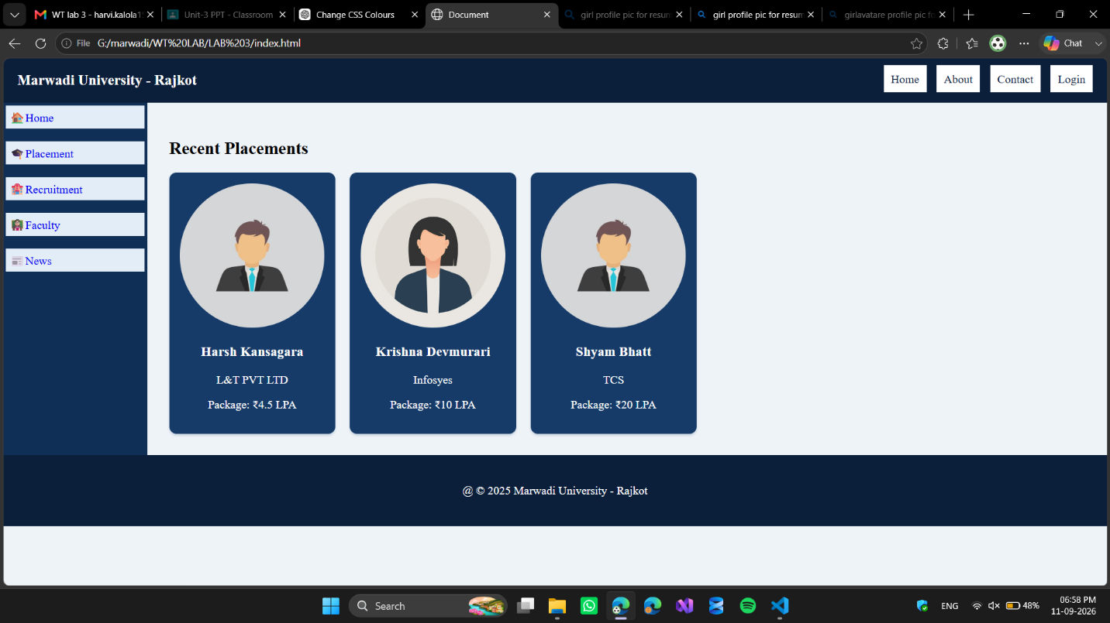

Code Snippet: index.html

<!DOCTYPE html>
<html lang="en">
<head>
<meta charset="UTF-8">
<meta name="viewport" content="width=device-width, initial-scale=1.0">
<title>Document</title>
<link rel="stylesheet" href="style.css" type="text/css"/>
</head>
<body>
<header>
<div class="logo">Marwadi University - Rajkot</div>
<nav class="top-nav">
<a href="#">Home</a>
<a href="#">About</a>
<a href="#">Contact</a>
<a href="#">Login</a>
</nav>
</header>
<div class="container">
<aside class="sidebar">
<a href="#">🏠Home</a>
<a href="#">🎓Placement</a>
<a href="#">🏩Recruitment</a>
<a href="#">👨🏻‍🏫Faculty</a>
<a href="#">📰News</a>
</aside>

<main class="content">
<h2>Recent Placements</h2>
<div class="cards">
<div class="card">
<img src="G:\marwadi\WT LAB\LAB 3\boy.jpg" alt="profile"/>
<h3>Harsh Kansagara</h3>
<p>L&T PVT LTD</p>
<p>Package: ₹4.5 LPA</p>
</div>
<div class="card">
<img src="G:\marwadi\WT LAB\LAB 3\girl.jpg" alt="profile"/>
<h3>Krishna Devmurari</h3>
<p>Infosyes</p>
<p>Package: ₹10 LPA</p>
</div>
<div class="card">
<img src="G:\marwadi\WT LAB\LAB 3\boy.jpg" alt="profile"/>
<h3>Shyam Bhatt</h3>
<p>TCS </p>
<p>Package: ₹20 LPA</p>
</div>
</div>
</main>
</div>
<footer>@ &copy; 2025 Marwadi University - Rajkot</footer>
</body>
</html>

Code Snippet: style.css

body
{
background-color: #eef3f8;
margin: 0px;
font-family: 'Times New Roman', Times, serif;
}
header
{
display: flex;
background-color: #0b1f3a;
justify-content: space-between;
padding: 20px;
}
.logo
{
color: #ffffff;
font-size: 20px;
font-weight: bold;
}
.top-nav a
{
text-decoration: none;
margin-left: 10px;
color: #0b1f3a;
background-color: #ffffff;
padding: 10px;
}
.top-nav a:hover
{
background-color: #d9e7f5;
text-decoration: underline;
}

.container
{
display: flex;
}

.sidebar
{
background-color: #102f56;
min-height: calc(100vh-50px);
width: 200px;
display: flex;
flex-direction: column;
align-content: space-between;
gap:10px;

}
.sidebar a
{
background-color: #e3edf7;
text-decoration: none;
padding: 5px;
margin: 4px;
}

.sidebar a:hover
{
background-color: #b8cfe6;
text-decoration: underline;
}
footer
{
background-color: #0b1f3a;
color: #ffffff;
padding: 40px;
text-align: center;
}

.content
{
flex-grow: 1;
padding: 30px;
}

.cards
{
display: flex;
flex-wrap: wrap;
gap:20px;
color: #ffffff;
}

.card
{
background-color: #163b68;
border-radius: 10px;
box-shadow: 0 2px 3px #c5d2df;
padding: 15px;
width: 200px;
text-align: center;
}

.card img
{
width: 100%;
border-radius: 50%;
}

